Assignment – 2 (Part 1 - Screen shots)
- Convert to PDF before submission on canvas

- Random number generated file screenshot
  - Screenshot the directory with file. For example:
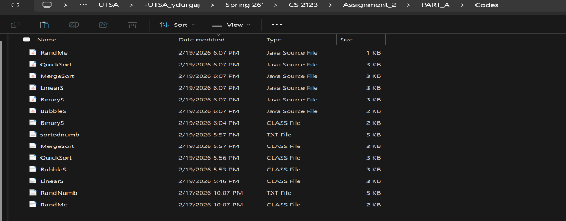
- CPU time taken by linear search for each number
  - Output screenshot
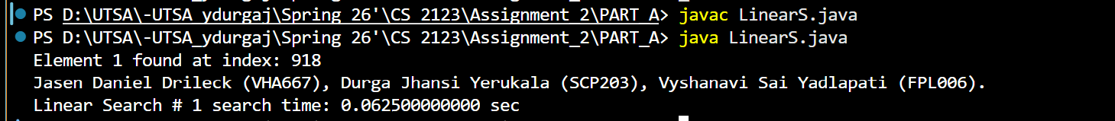
    - <Image> “Student or Group names and ABC123. Linear Search # 1 search time: <time in sec>”

  - Output screenshot
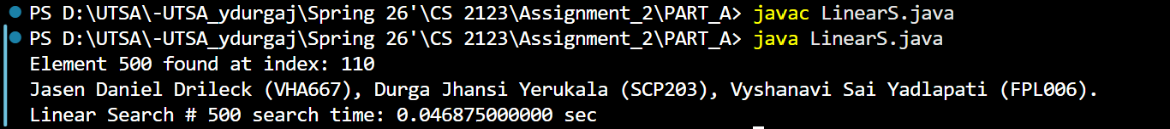
    - <Image> “Student or Group names and ABC123. Linear Search # 500 search time: <time in sec>”

  - Output screenshot
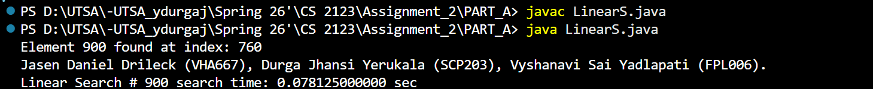
    - <Image> “Student or Group names and ABC123. Linear Search # 900 search time: <time in sec>”

- CPU time taken by different sorting algorithms
  - Output screenshot
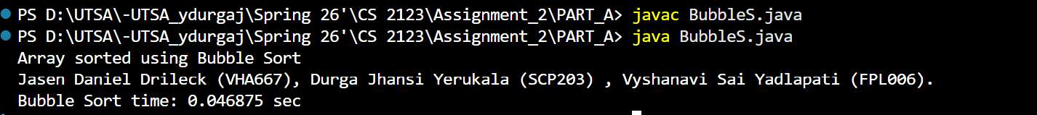
    - <Image> “Student or Group names and ABC123. Bubble Sort time: <time in sec>”

  - Output screenshot
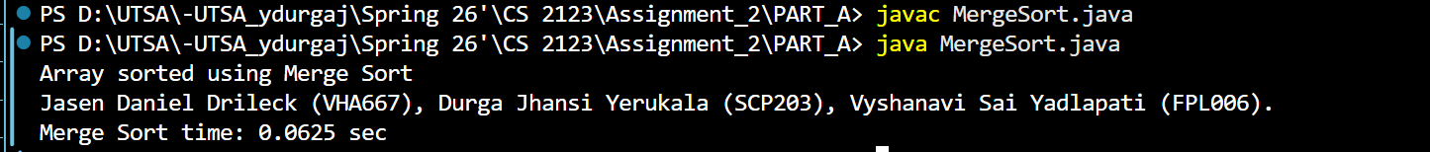
    - <Image> “Student or Group names and ABC123. Merge Sort time: <time in sec>”

  - Output screenshot
    - <Image> “Student or Group names and ABC123. Quick Sort time: <time in sec>”

- CPU time taken by Binary search for each number
  - Output screenshot
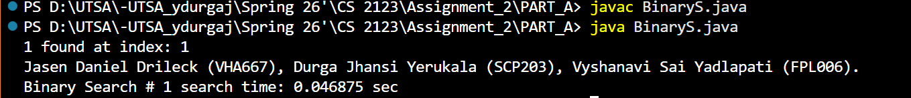
    - <Image> “Student or Group names and ABC123 Binary Search # 1 search time: <time in sec>”

  - Output screenshot
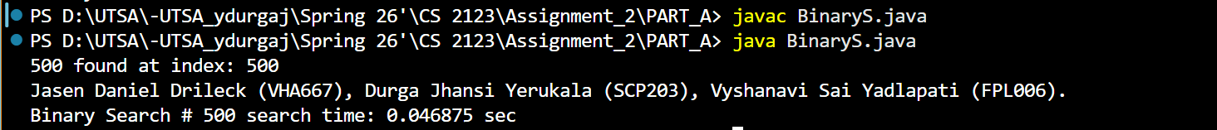
    - <Image> “Student or Group names and ABC123 Binary Search # 500 search time: <time in sec>”

  - Output screenshot
    - <Image> “Student or Group names and ABC123 Binary Search # 900 search time: <time in sec>”

